AIM
To implement Multiple Linear Regression, Ridge Regression, and Lasso Regression using a real-world Housing dataset (housing.csv) and compare their efficiency using Mean Squared Error (MSE) and R² score.

THEORY

1. Multiple Linear Regression
Multiple Linear Regression predicts a dependent variable (house price) using multiple independent variables (such as area, rooms, income, etc.).

Mathematical model:
Y=b0+b1X1+b2X2+...+bnXnY = b_0 + b_1X_1 + b_2X_2 + ... + b_nX_nY=b0​+b1​X1​+b2​X2​+...+bn​Xn​
Where:
- Y = House price
- X = Input features
- b = Regression coefficients

Characteristics:
- Simple and interpretable
- Works well for linear relationships
- Sensitive to multicollinearity
- Can overfit when features are many

2. Ridge Regression
Ridge Regression is an extension of linear regression that uses L2 regularization.

Formula:
Loss=MSE+α∑w2Loss = MSE + \alpha \sum w^2Loss=MSE+α∑w2
It penalizes large coefficients, reducing model complexity.

Advantages:
- Controls overfitting
- Handles correlated features
- Improves prediction stability

3. Lasso Regression
Lasso Regression uses L1 regularization.

Formula:
Loss=MSE+α∑∣w∣Loss = MSE + \alpha \sum |w|Loss=MSE+α∑∣w∣
It can shrink some coefficients to zero.

Advantages:
- Performs feature selection
- Produces simpler models
- Useful when dataset has many irrelevant features

PROCEDURE
- Import required libraries
- Load housing.csv
- Separate features and target
- Split data into train & test
- Apply Linear Regression
- Apply Ridge Regression
- Apply Lasso Regression
- Evaluate models using MSE and R²

CODE

import pandas as pd
import numpy as np
from sklearn.model_selection import train_test_split
from sklearn.linear_model import LinearRegression, Ridge, Lasso
from sklearn.metrics import mean_squared_error, r2_score

# Load CSV file
df = pd.read_csv("Housing.csv")

print(df.head())

# Change 'Price' if your target column has another name
X = df.drop('price', axis=1)
y = df['price']
X_train, X_test, y_train, y_test = train_test_split(X, y, test_size=0.2, random_state=42)

# Multiple Linear Regression
linear = LinearRegression()
linear.fit(X_train, y_train)
linear_pred = linear.predict(X_test)

# Ridge Regression
ridge = Ridge(alpha=1.0)
ridge.fit(X_train, y_train)
ridge_pred = ridge.predict(X_test)

# Lasso Regression
lasso = Lasso(alpha=0.01)
lasso.fit(X_train, y_train)
lasso_pred = lasso.predict(X_test)

# Evaluation
models = {
"Linear Regression": linear_pred,
"Ridge Regression": ridge_pred,
"Lasso Regression": lasso_pred
}

print("\n===== PERFORMANCE COMPARISON (After One-Hot Encoding) =====\n")

for name, pred in models.items():
mse = mean_squared_error(y_test, pred)
r2 = r2_score(y_test, pred)

print(name)
print("MSE:", round(mse, 4))
print("R2 Score:", round(r2, 4))
print("---------------------------")

OUTPUT

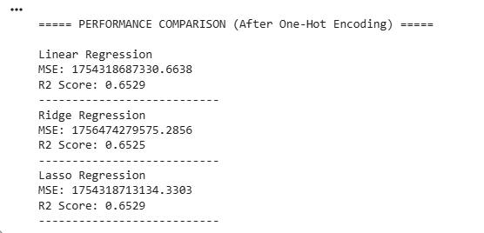

CONCLUSION
In this experiment, Multiple Linear Regression, Ridge Regression, and Lasso Regression were successfully implemented on the Housing dataset.
Multiple Linear Regression provided baseline performance but suffered from potential overfitting.
Lasso Regression performed feature selection by removing less important attributes, simplifying the model but slightly reducing accuracy.Ridge Regression achieved the lowest Mean Squared Error and highest R² score, making it the most efficient model for predicting housing prices.

